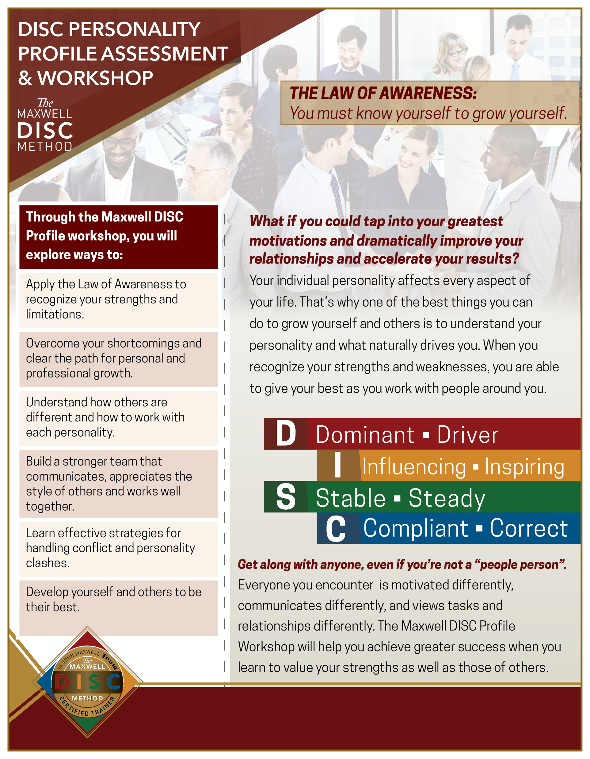

*Contact me to schedule a DISC Workshop for your company.*

**Terri Barthol | 610-804-2500**